Project Editing: Planning and Discussion 3

Current Feature Capabilities & Future Direction
Edit syncing is a known feature expansion planned loosely for Q2 2026.
Today, editing is supported only through downloaded AIP files. This capability is limited because files can’t be reuploaded to the SpecterX platform and changes are not synced.
Planning for feature expansion for MVP needs to allow sync changes at a minimum, from the SpecterX Viewer and ideally across supported opening applications.

Discussion - March 24th, 2026
Attendees:
- Guy
- Ido
- Loren

Discussion - March 17th, 2026
Attendees:
- Ido
- Guy
- Artem
- Loren

Scope begins with reupload within the same workspace. This would require a clear distinction between Workspaces and Folders.
- Workspace will be the only space where files can added by users other than the owner
  - Files CAN be uploaded to a folder within a Workspaces
- Only owners can upload files to existing folders

Down the road, folders could be shared as Folders or Workspaces and Folders could be converted to a Workspace.

File lifecycle note – could there be a path to add an identifier or tracking element for non-AIP files. We would use this to properly identify ownership AND use this as a security feature in the future.

Versioning
- Bare minimum – the version the owner had and the version that will be overwritten
- We would need a UI for the owner to compare versions and make the decision to override OR save as new copy

Research/planning needed
- Mechanism for versioning support utilizing customer storage
  - Ido suggests possible Git mechanism for comparing versions
- Mapping out of user workflows for upload and multiple copy consolidation
  - Notification flow for owner and merge when multiple recipients have downloaded
- Locking AIP or reauthorship
  - Need to look at path to co-authorship with editing locally and Viewer
  - Constraint – if live editing will be supported, the other platform must be locked – we cant support live editing in both AIP and an online viewer

Progressive Plan
- Step 1 - v1.21:
  - Duplication by name will be recognized when owner is uploading a file of the same name to their My Files
  - Notification prompts to save new or use existing – no viewer for comparison
  - We would need version comparison – research needed here
    - Backend - How would we implement backend architecture to support versions for a file
    - Frontend - look for a library that allow to highlight changes
- Step 2:
  - Allow this in Workspace with the Owner of the workspace allowing decision to override or keep as copy - non encrypted files only

    - Notification flow to prompt owner to consolidate duplicates
- Step 3:
  - Allow workflow for Workspaces with SpecterX AIP encrypted files

Discussion - March 9th, 2026
Attendees:
- Guy
- Loren
- Bloch

Separating out the editing steps allow us to reach a better end case:
- Recognize the duplicate upload and replace my own file at upload “We recognize a file of the same name that YOU own - do you want to replace it or make a copy”? – (Specifically in the webUI?)
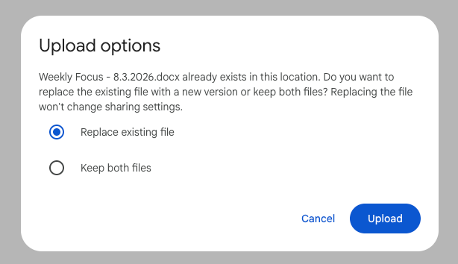

- Other peoples files – asking the actual owner for their decision? The owner needs to approve it.
  - This is workspaces
- Then do override vs copy
  - And if not the owner, get the permission to override
  - Could approach ownership transfer
- Then it is AIP file

Discussion Notes - March 4th, 2026
Attendees:
- Guy
- Loren
- Bloch
- Shahar

Approach of implementing OnlyOffice:
- OnlyOffice replaces WOPI+OfficeOnline
- Decision needed to lock the document while one user is editing
- This is a better option that iframing Sharepoint (Shahar’s suggestion) as Sharepoint isn’t intended for this
  - Clarification – when we are talking about Sharepoint as a viewer, we are talking about accessing OfficeOnline via Sharepoint

Considerations for Sharepoint Connector:
- Sharepoint Connector is currently set up for view only sharing.
  - We would need to consider that changes are made directly to the reference file
  - We need to consider conflict changes when changes are made in Sharepoint at the same time as changes are made by an editing recipient

Conclusion:
- OnlyOffice will be for the viewer replacement of Wopi
  - 1st step would simply be to replace the viewer event before editing
- Editing will be supported also AIP downloads
  - Resynced at upload
- Locking will be required to allow only 1 editor at the same time
- Both need to follow the same logic of owner vs uploader
  - Reuploading a protected file should produce the same results as editing via our online editor.

Discussion Notes - March 3, 2026
Attendees:
- Guy
- Loren

Guy wants to implement Only Office as the Viewer replacement. We will discuss the team call on March 4th.

Nimrod would like us to explore Co-Authoring as described in this Microsoft Documentation.

Discussion Notes - Feb 18th, 2026
Agenda: Discuss the initial approach and considerations to allow edit syncing.

Attendees:
- Shahar
- Ido Bloch
- Loren

Shahar initial perspective:
- Main goal of MVP to edit a document and sync the changes back
- To allow, we would need 2 main components:
  - 1 that makes sure 2 people can’t edit at the same time
  - Enable viewing in the applications we support:
    - 365
    - Google
    - Viewer

Versioning and counting copies of files:
- Versioning as industry knows it across Office and Google, won’t be approached in MVP, but syncing changes to a new copy or the existing copy will be needed

Technical considerations
- (Ido) This would require edited copies to override the copy in storage
  - Sync is more complex than PDF signature because it has to go through 2 services: WOPI & OOS
- Guy’s initial idea was to begin with SPX viewer only
- (Shahar) suggests we may want to replace our viewer with a singular view that can support editing of both PDFs and Office files
  - Shahar suggests we embed our own Sharepoint online as the opening mechanism. This is different from opening if 365 where it is shared directly to the users account
  - Suggesting this change because it would broaden the capabilities available for editing over existing viewer

Goals for MVP per this initial discussion:
- Implement edit syncing through online viewer
- Lock mechanisms to control concurrent editing - all the rest gets read only
  - OR choose one platform and allow live collaboration
  - Bloch things live collaboration might be easier to achieve rather than implementing locks
- When assigning collaborator roles, the sender would determine if edits should be synced back to the existing file or new copy
- Remedy for current editing AIP with this MVP:
  - Could turn off editing for AIP downloads
  - OR allow editing and only sync changes OR new copy under the original owner on reupload to SpecterX
  - OR change the way we handle AIP so that downloaded actually references a file still held by SPX

Next Steps:
- 1st step would be to research replacement of WOPI
- 2nd would be to decide if the approach is live collaboration or locking mechanism
  - Locking mechanism would only be needed if you allow edit syncing in multiple platforms.

